MUNICIPAL BUDGETARY EDUCATIONAL INSTITUTION
Tosno Secondary School №3
named after Hero of the Soviet Union S. P. Timofeev»

PROJECT WORK ON THE TOPIC:

IDIOMS AND PHRASEOLOGICAL UNITS IN ENGLISH
(Project work in English)

Performed by:
Ekaterina Dvoretskaya, 7th "A"class,
Tosno Secondary School №3
Supervisor: Tatyana Krutova,
The teacher of English

Tosno
2021-2022

Content
1.THEORETICAL PART
Introduction……………………………………………………………………3
1.1 Definition of the idiom and its place in the English language……………4
1.2 Themes idioms…………………………………………………………….5
1.3 Translation difficulties…………………………………………………….6
1.4 Methods of memorizing idioms…………………………………………..7
1.5 Multimedia application for learning idioms………………………………7
1.6 The need to learn idioms at school………………………………………..8
2. PRACTICAL PART
2.1 Survey and diagnosis of the level of knowledge of the idioms
among middle school students ………………………………………………..9
2.2 Compilation of the most popular idioms dictionary
in the English language……………………………………………………….10
2.3 Creating cards with idioms in multimedia applications Quizlet …………14
Conclusion.....................................................................................................15
List of used literature………………………………………………………….16
Appendix 1…………………………………………………………………....17
Appendix 2…………………………………………………………………....18
Appendix 3……………………………………………………………………19

INTRODUCTION

Purpose: to determine the importance of the meaning of idioms for learning English and introduction with the idioms.
Tasks:
1) Study the literature and literary sources about the features of idioms
in English.
2) Identify the most popular idioms and make a short dictionary
idiom.
3) Explore the popular multimedia study app
idiom.

Relevance: Learning English as the language of international communication in the modern world is necessary. When studying it and communicating, idioms are often used, which can be difficult to understand, despite the fact that we know the translation of all compound words.

THEORETICAL PART

1.1 Definition of an idiom and its place in the English language.
An idiom is a combination of language units, the meaning of which does not coincide with the meaning of its constituent elements. Since most idioms are used mainly in colloquial speech, and are not typical of written language or formal situations, we can say that idioms make our speech “live”, figurative and colorful, close to the speech of native speakers.
In other words, an idiom is a phrase that has a figurative meaning. The words of which it consists, that is, components, cannot be translated separately, because the meaning of the idiom itself will be lost. The meaning of the entire expression is not determined by the meaning of its constituent words. Often the meaning of an idiom is difficult to guess, to understand from the words included in it, if you are not familiar with it.
There are thousands of idioms in the English language, but it is impossible to give an exact number, and it is also impossible to give an exact number of words in the language. However, phraseological units are very beautiful and original, they reflect the thoughts and feelings of the people, so I chose them as a topic for my work.
Without knowing the idioms of the target language, you can get into trouble when communicating with a foreigner, despite the fact that you know the translation of all compound words. You need to know idioms in order not only to understand the authentic speech of native speakers, but also to participate in the communication process yourself.

1.2 Themes of idioms.
Theme: house
1) Nothing to write home about - So they say about any unremarkable events in our lives that have not been preserved in our memory.
2) Darken somebody's door -To come as an unexpected, unwanted guest.
3) Put house in order - Deal with your problems.
Theme: colors
1) White lie - Lies for good.
2) Feel blue -Feel longing.
3) Yellow dog - Mean person, coward
Theme: animals
1) For the birds - Something that is not good, something useless.
1) The dog days- Very hot days.
2) That cat won't jump- This number will not work.
Theme: food
1) It's not my cup of tea - This is not to my taste.
2) Big cheese- Important person, boss
3) It is a hot potato- This is a sensitive topic.
Theme: weather
1) For a rainy day- For a black day.
2) Chase rainbows- Chasing the impossible.
3) To feel under the weather - Feel bad.
1.3 Difficulties in translation.
Difficulties in translating phraseological units begin with their recognition in the text. In almost any language, there are several levels of phraseological units: fixed in the dictionary and known to everyone; obsolete, but marked with a dictionary; known to everyone, but for some reason not recorded in the dictionary; known to certain social groups.
The first and most important condition in any case is to be able to recognize phraseological units in the text, in contrast to free language units. The most productive way is the skill of highlighting units that contradict the general meaning in the text, since, as a rule, it is the appearance of such units that indicates the presence of a figurative meaning.
Therefore, as soon as an expression appears in the text that logically contradicts the context, it should be considered as a possible phraseological unit.
Most often, there are four main difficulties in translation: the accuracy of the translation (polysemy), the preservation of lexical meaning.
Very often there is such a problem as the problem of saving the style. After all, outdated idioms come across, sometimes reduced vocabulary is used or, conversely, high-style vocabulary, translation variability and preservation of the narrative style. Required for translation to take into account stylistic coloring and try to convey this feature of speech.

1.4 Ways to memorize idioms.
1) Associations. This is a memorization technique that can be used in any situation. Phraseologisms themselves suggest its use: you just need to combine in images the meaning of the idiom itself and with its literal meaning. Then the complexity of idioms turns into an advantage in their study.
2) Separation by topics. Break idioms into blocks to structure information.
3) Search for analogues. Many idioms in English and Russian have the same source, such as idioms with biblical origins. Comparing phraseological units in two languages, one can see cultural similarities and differences in the perception of situations.
1.5 Multimedia application for learning idioms.
For memorizing words, expressions, terms, formulas, etc. there is an online service. Quizlet is a service for creating flashcards, tests and several types of exercises that will help you remember many different idioms. This is a great option for learning idioms.
In this application there is a course of English idioms. In it, idioms are divided into thematic groups by topic, and for each idiom a picture is selected according to the meaning in the “learning” section, because of this study it becomes even more interesting. There are 7 modules in total, each with 12 idioms. In the "cards" section, you can test your knowledge of the meanings of idioms, and in the "writing" section, you can test your ability to translate idioms. In the "selection" section, you can choose the right word for an idiom. And at the end, it is proposed to test your skill in mastering the learned idioms and take a test.
You can go to the site thanks to a special QR code (Appendix 2).
1.6 The need to study idioms at school.
Idioms begin to be learned in high school. They develop our speech and make it more diverse. Idioms replenish students' vocabulary and reflect the culture of native speakers.
Knowledge of English set expressions fully helps enjoy reading original English texts, vividly characterize the level of language proficiency of the speaker. English set expressions not only decorate speech, they also allow shorten speech (even to two or three words). Speech using еnglish idioms become more beautiful and slender.
Getting acquainted with phraseological units in English lessons, we became interested in this topic. After all, as Alexander Vladimirovich Kunin, the largest specialist in the phraseology of the English language, said: “Phraseology is a treasury of the language.” Idioms not only reflect the culture and life of a particular language, but also help to make speech more expressive and emotional. Phraseologisms often have a clearly national character. The object of phraseology is so complex and specific that its study provides new data enriching lexicology, semantics, language history, etymology, and general linguistics.

PRACTICAL PART

2.1 Questioning and diagnostics of the level of knowledge of idioms among
middle school students.
I conducted a survey among students of the 7th А grade. 30 teenagers took part in the survey. The questionnaire consisted of 3 questions (Appendix 1). I suggested that for a modern student, the study of idioms would be interesting and informative.
To the question: “Do you know what an idiom is?” the answer was positive only in 30% of the class.
Answering the question: “Have you ever studied idioms?”, Almost all of my classmates answered that they had never studied them before.
Another question in the survey: "Would you like to learn idioms?" showed that 77% of those surveyed expressed a desire to learn idioms.
The results of the survey showed that students are interested in learning and familiarizing themselves with English idioms.
Diagram 1

Diagram 2
Diagram 3

2.2 Compiling a dictionary of the most popular idioms
in English.
Theme: weather
storm in a teacup - a storm in a teacup, a lot of noise about nothing
chase rainbows - chase the unattainable
lightning-fast - fulminant
have one's head in the clouds - soar in the clouds
be under the weather - be unwell
under and cloud - under suspicion
bolt from the blue - like snow on the head
weather the storm - survive hard times
in a fog - confused
go down a storm - succeed
Theme: time
Crack of dawn- Dawn, sunrise, very early morning
To call it a day/night- Finish (usually work); consider (the case) completed; round off
In the nick of time - just in time
To have a whale of a time - have a good time, have fun.
once in a blue moon - very rare
have the time of one's life - have a great time
for donkey's years - from time immemorial
pressed for time - in a hurry
be ahead of time - get ahead of
go with the times - keep up with the times
Theme: animals
monkey business - meaningless work
top dog - winner
cash cow - source of funds, cash cow
black sheep - white crow
like a cat on a hot tin roof - to be at ease
in the doghouse - out of favor
horse around - fool around
lion's share of something - the lion's share
eat like a horse - have a wolfish appetite
have a tiger by the tail - defy fate
Theme: money
Pay through the nose - pay dearly, pay with interest.
Splash out - spend money generously
Throw money at something - spend money on something
To make a fortune - get rich, make a fortune
gravy train - easy money
Money burns a hole in someone's pocket - money does not stay in your pocket for a long time, money burns your hand.
Dirty cheap - very cheap, half price
To be well-off- to be wealthy
A money spinner -profitable business

Theme: food
A piece of cake - easier than a steamed turnip
An apple-pie order - complete order
Bad egg - thief, swindler
Beef something up - strengthen
Bread-and-butter letter - letter of thanks
It's as easy as pie - easy peasy
To be full of beans -Be energetic
Cry over spilled milk - be sad about what cannot be changed

2.3 Create idiom flashcards in the Quizlet multimedia app.
As part of the creation of this project, I myself created flashcards for memorizing idioms quickly in the Quizlet app.
https://vk.com/away.php?to=https%3A%2F%2Fquizlet.com%2F_b4lgwp%3Fx%3D1qqt%26i%3D4af270&cc_key=
-using this link, you can go to the Quizlet website to view the cards with idioms created by me.
I have attached the process of creating idiom cards (screenshots from the Quizlet website) in appendix 3.
Conclusion
The English language is becoming more and more deeply embedded in our lives. It is very rich in idiomatic expressions that are constantly found in literature, in newspapers, in films, in radio and television broadcasts, as well as in the everyday communication of the British, Americans, Canadians, Australians. English idioms, very varied, are quite difficult for English learners. Of the languages ​​​​known to science, there are none in which there would be no idioms, phraseological turns, proverbs and sayings at all.
On the one hand, idioms enhance the uniqueness and individuality of the language, but on the other hand, the use of idioms makes it difficult to understand and translate from a foreign language into a native one and vice versa. Despite the fact that online translators are very popular in the modern world, they do not always give the correct version of the translation.

List of used literature
1) Alekhina A.I. Idioms of modern English. - Minsk. 1982.
2) Arnold I.V. Stylistics. Modern English: a textbook for universities, Flint ed.: Science, 2010.
3) Vinogradov V.S. Introduction to translation studies. - M., 2001
4) Grigoryeva A. I. 1500 Russian and 1500 English idioms, phraseological units and set phrases. - Vladimir: VKT, 2012.
5) Gurevich, Zh.A. _ Brief Russian-English Phraseological Dictionary: / Zh.A. Gurevich. - Russian language, 1991.
6) Dubrovin M.I. Russian and English idioms. – M.: ILBI, 2001.
7) Kunin A.V. English-Russian phraseological dictionary. - M.: Russian language, 2004.
8) Kunin A.V. Phraseology course of modern English: textbook. for in-t and fact. foreign lang. - 2nd ed., revised. - M .: Higher. School, Dubna: Ed. Center "Phoenix", 1996.
9) Litvinov P.P. English-Russian Phraseological Dictionary / P.P. Litvinov. "VAKO", 2008 - p.336.
10) Logan P. Smith Phraseology of the English language. M., 2002.
11) Parshin A. Theory and practice of translation. – M., 2008.
12) Smirnitsky A. I. Lexicology of the English language, M., 1956;

Appendix 1.
Questionnaire:
1. Do you know what idiom means?
____________________ ( Yes/no)
2. Have you ever learned any idioms?
_____________________ (Yes/ /no)
3. Would you like to learn new idioms?
______________________ ( Yes/no)

Appendix 2
QR code for downloading the Quizlet multimedia application for learning, memorizing and checking the level of assimilation of memorized idioms.

Appendix 3
How to create quick idiom flashcards in the Quizlet multimedia app:
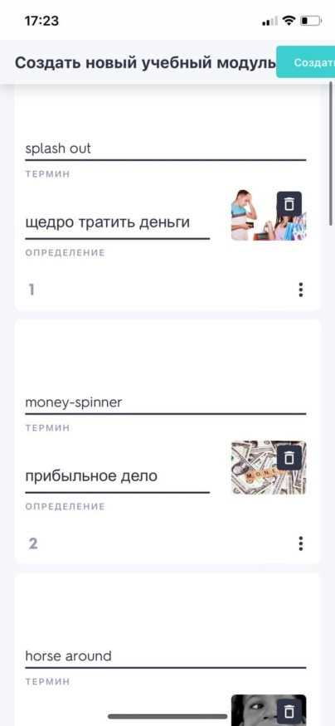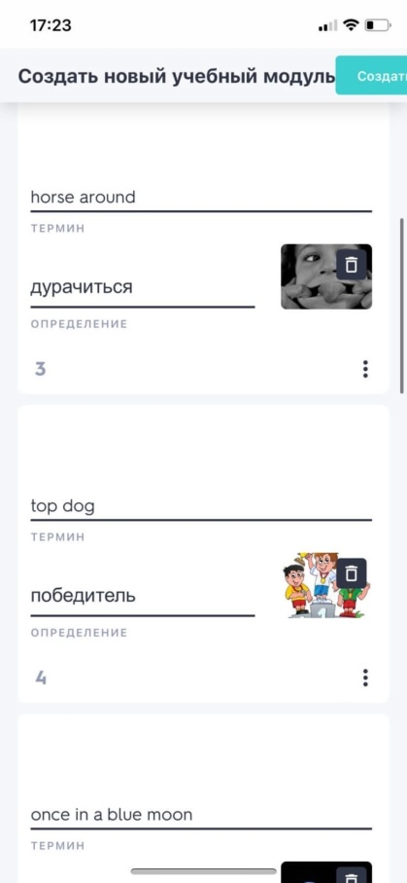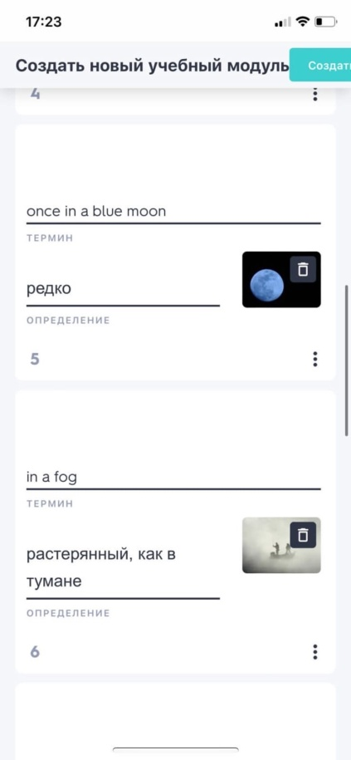

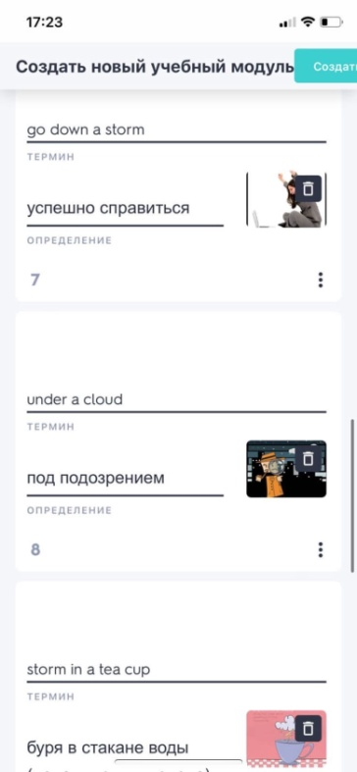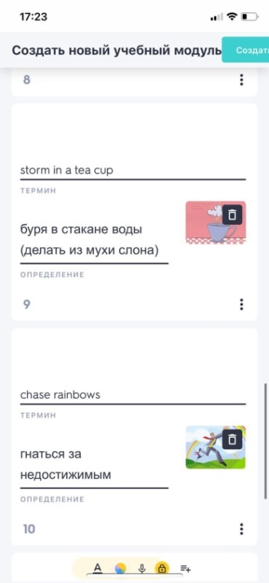

Smirnitsky A. I. Lexicology of the English language, M., 1956
Dubrovin M.I. Russian and English idioms. – M.: ILBI, 2001.
Litvinov P.P. English-Russian Phraseological Dictionary / P.P. Litvinov. "VAKO", 2008 - p.336.
Electronic service Quizlet
Grigoryeva A. I. 1500 Russian and 1500 English idioms, phraseological units and set phrases. - Vladimir: VKT, 2012
Kunin A.V. English-Russian phraseological dictionary. - M.: Russian language, 2004.

